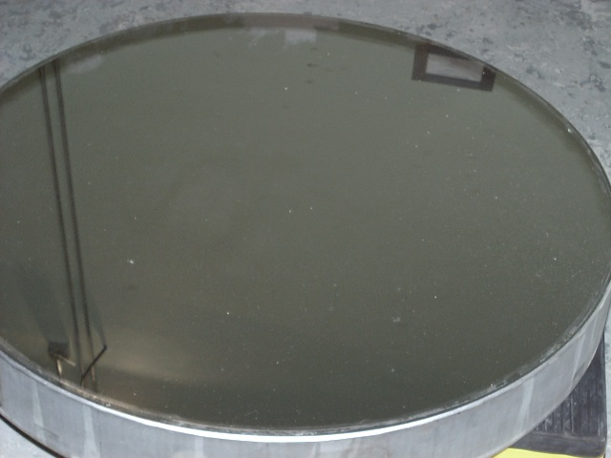

The Coude secondary mirror. The last aluminization was 5 years ago.

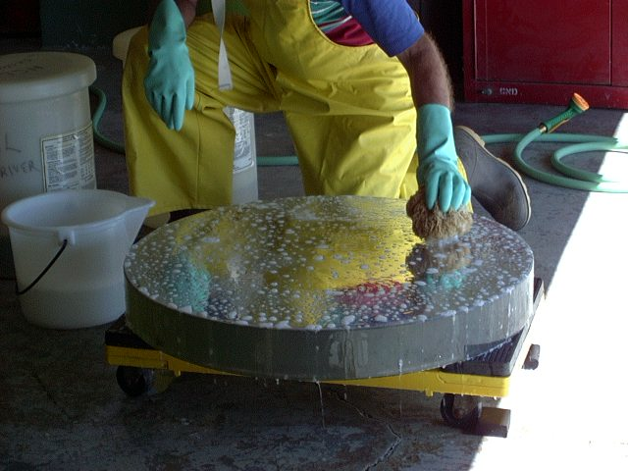
Process begins with a tap water rinse and, followed by gentle Orvis soap wash with a natural sponge. Care is taken not to drag the sponge on the surface, but to ‘blot’ with copious amounts of soap solution. The intent is to remove large particles.

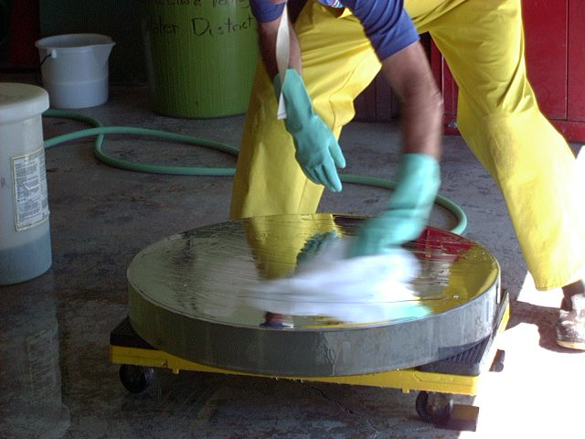
After soap wash, another rinse with tap water, then the surface is partially dried using lab Kaydrys, gently dragging the wipe over the surface to remove most of the standing water.

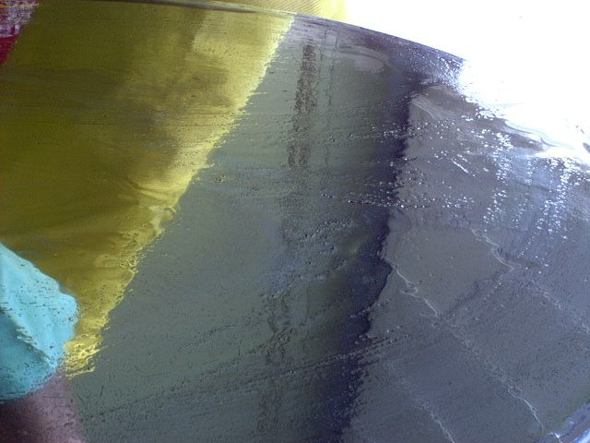

The next step is to apply a mixed solution of hydrochloric acid and cupric sulfate, applied liberally with a wad of Kaydrys. Blotting and very gentle wiping will eventually remove the aluminum coating. In the second photo, you can see the aluminum start to lift off the surface.

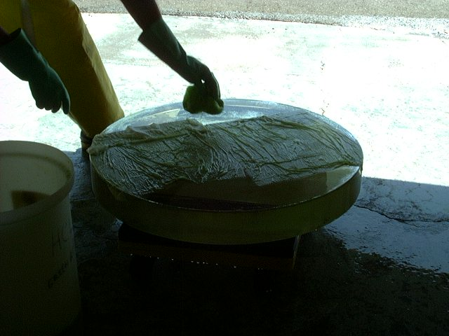
In areas where aluminum resists removal (this mirror is SIO overcoated, making stripping more difficult), a technique is to lay Kaydrys on the surface and saturate with stripping solution, and allow to remain for a time. Don’t allow to dry, however.

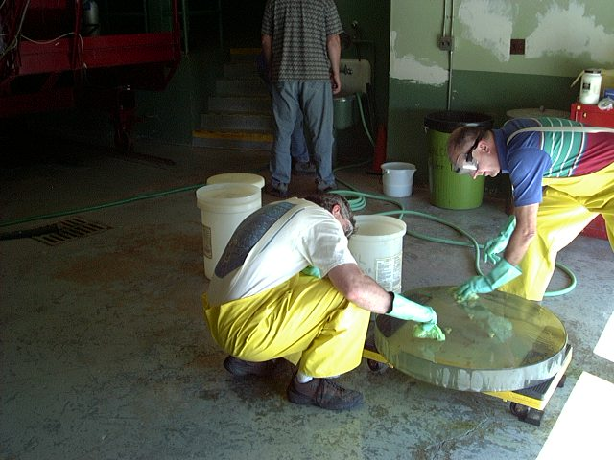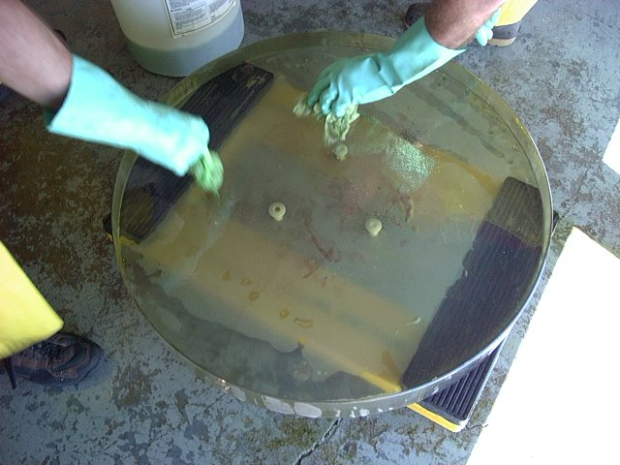

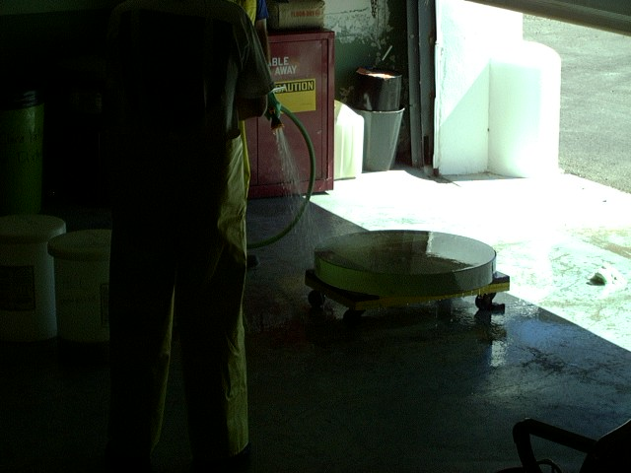
After awhile, all traces of aluminum will be gone. Again, after this process, rinse with tap water.

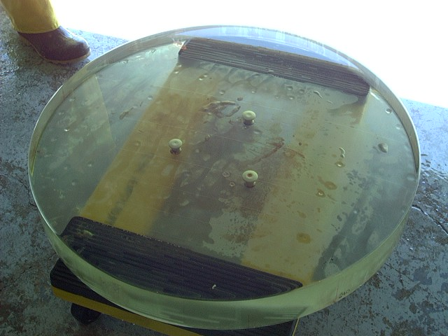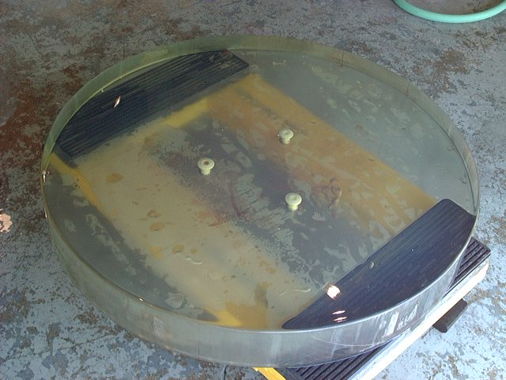
No more aluminum!

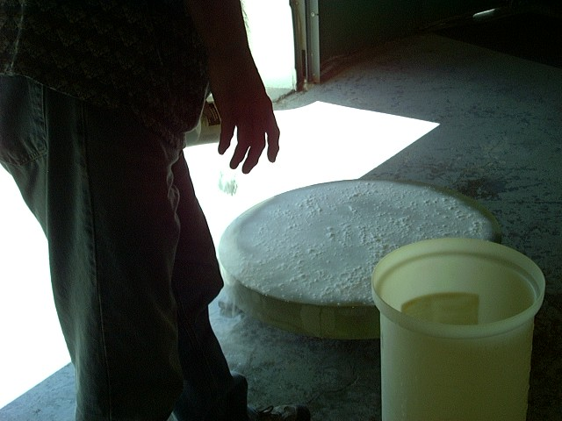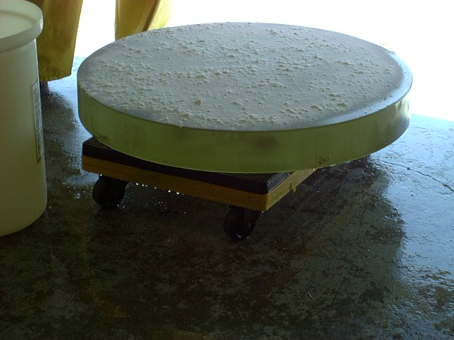

Apply a solution of potassium hydroxide to the surface, then sprinkle on a layer of calcium carbonate.

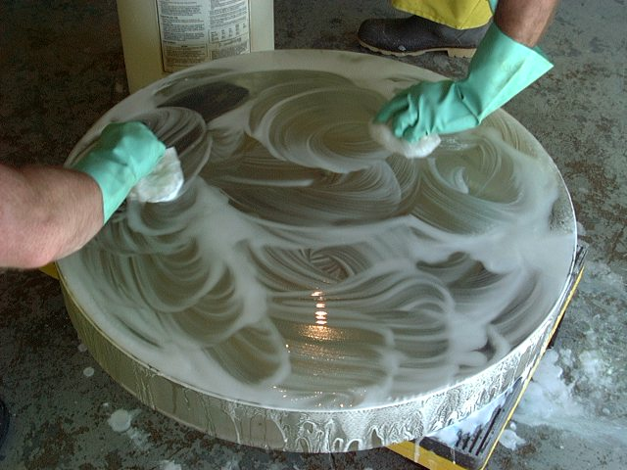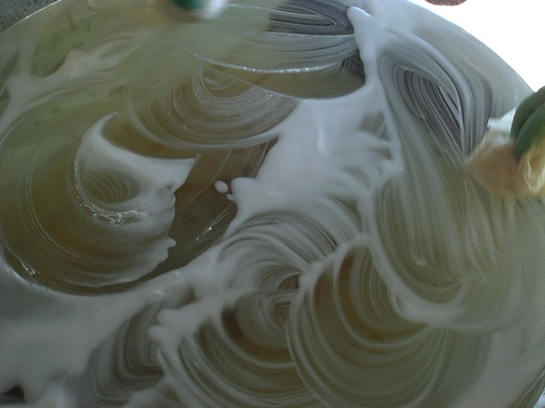

Using the solution of potassium hydroxide, gently rub the calcium carbonate onto the surface, using moderate pressure. It’s important to only work the surface; don’t bring solution from sides of glass up onto surface, as it may contain remnants of grinding compound. After thorough rubbing, rinse once again with tap water.

At this point, a solution of hydrochloric acid is applied, and then rinsed off with tap water.

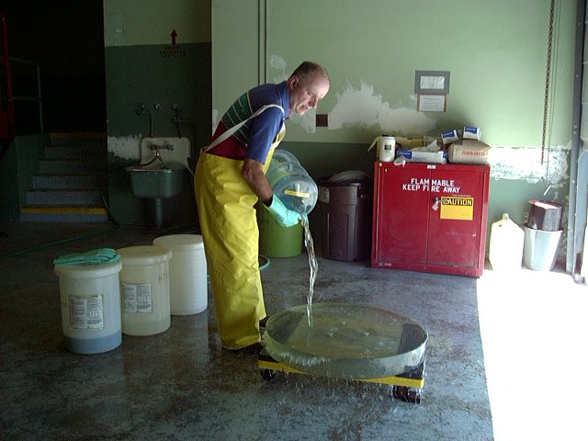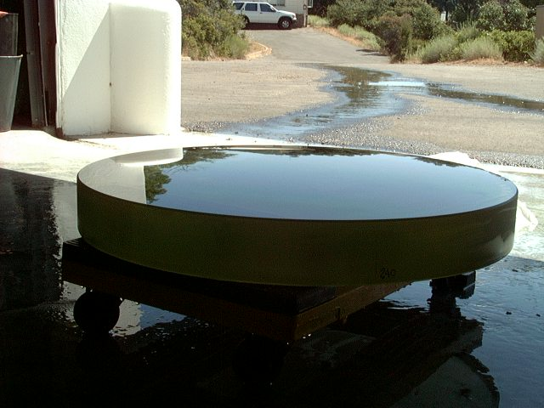

After tap water rinse, thoroughly rinse with distilled water. Quantity used is about 7 gallons. Water will form a nice even layer (no beading, which would indicate some sort of contamination).

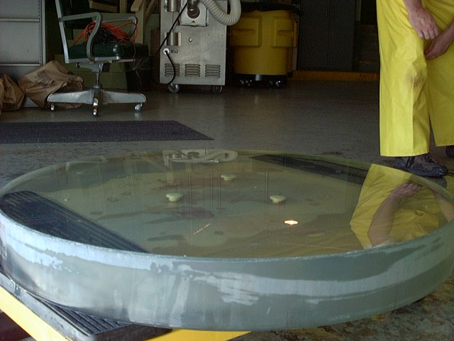
Using Kaydrys, quickly dry surface. The trick is to not allow water droplets to form. Again, use care not to introduce water from sides of glass onto surface.

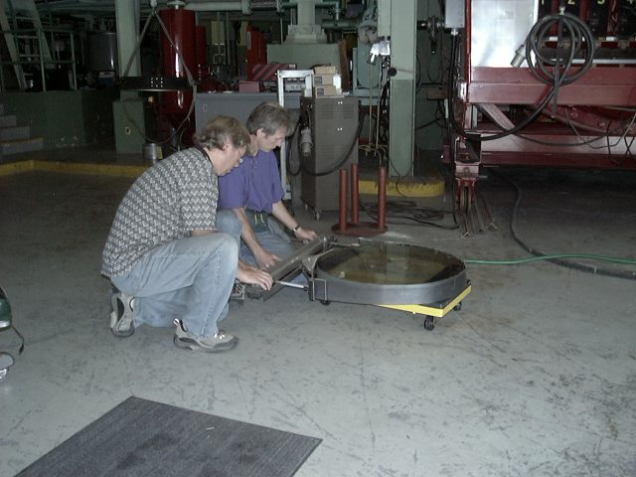
Glass is then secured into lifting fixture prior to insertion into coating chamber.

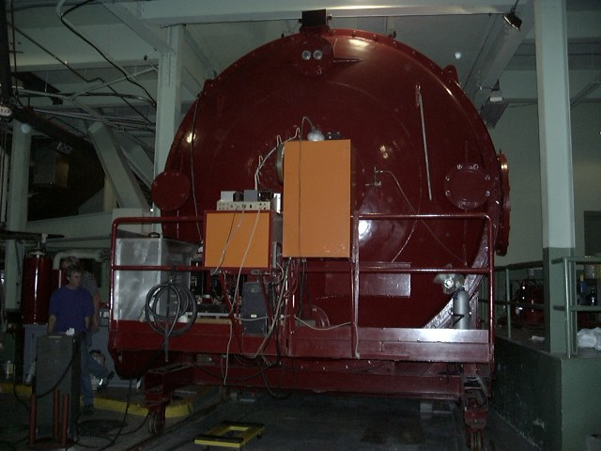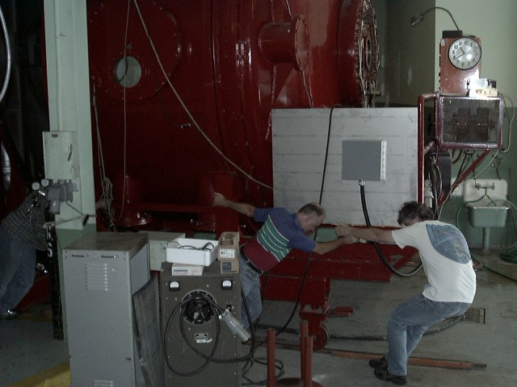
The coating chamber on Mt. Hamilton. Opening it takes a fair amount of muscle power.

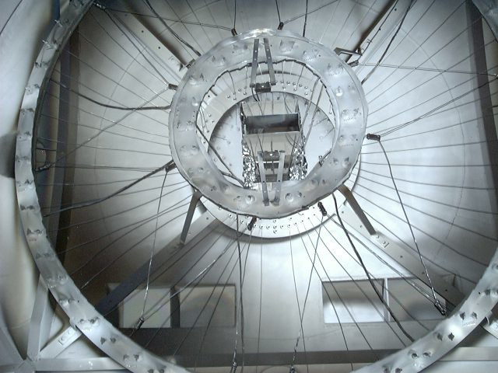
The business end of the coating chamber. This is where the filaments and the aluminum clips are mounted.

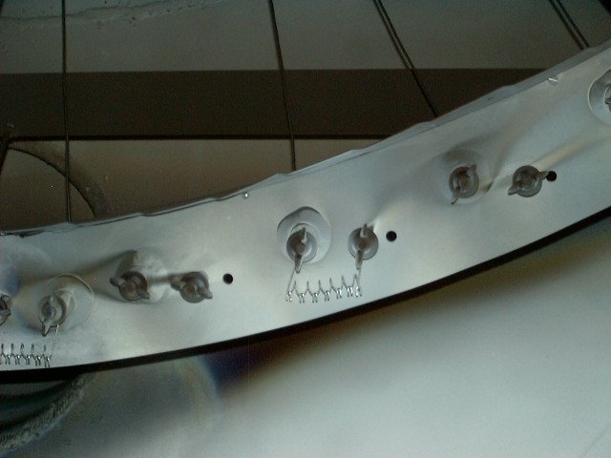
Close-up shot of a filament with attached aluminum clips.
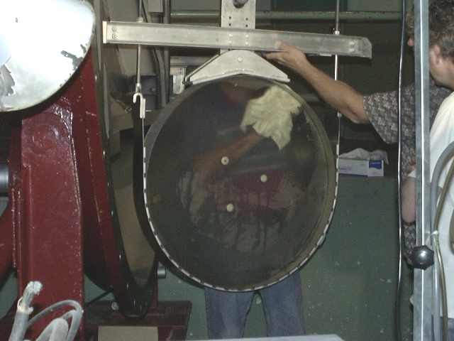
Once hanging from the hoist, the back side of the glass gets cleaned with isopropyl alcohol.

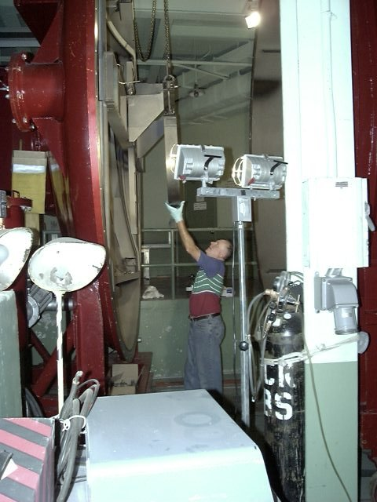
The glass is hoisted into final position in the chamber.

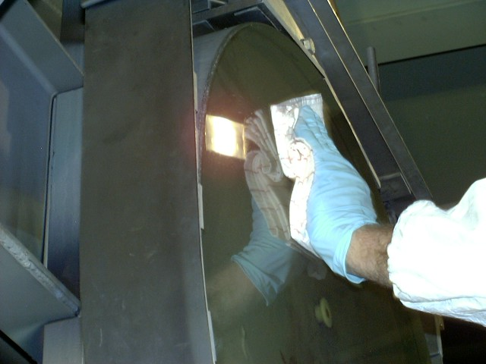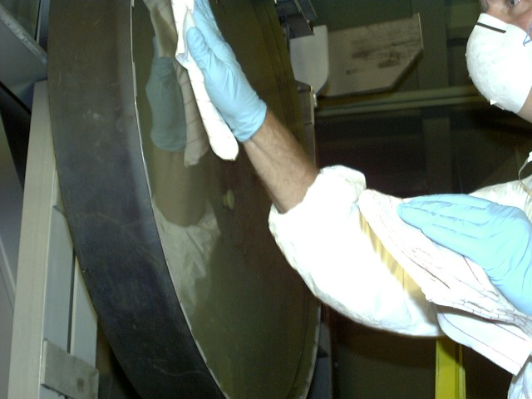
With the mirror in position, the surface is cleaned and dried with isopropyl alcohol and lint-free cloths (one soaked with alcohol, one for drying). Small segments at a time are worked, so as to not allow the alcohol to evaporate. It is important here to use high-intensity lights (as seen in the photo on the left, above), and view the surface at a glancing angle, which allows better viewing of dust and streaks.

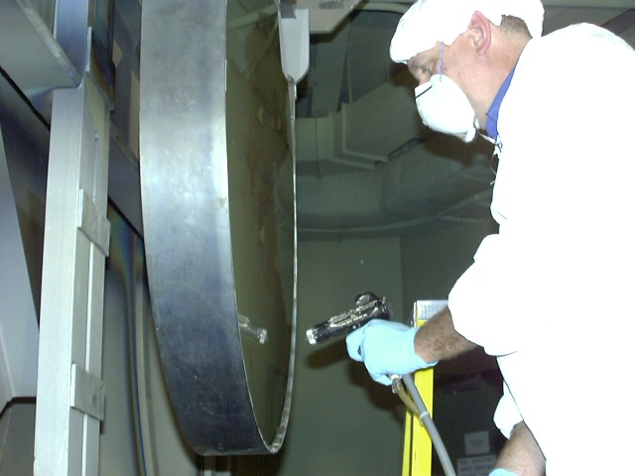
The final step is to blow off the surface with dry nitrogen through an anti-static gun, working from top to bottom. A final check of the surface is done, and if needed, spot cleaning with alcohol, and a blast with the nitrogen air gun. The chamber is then closed, and aluminization begins.

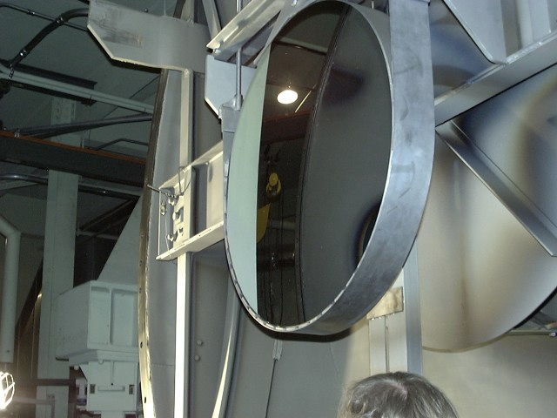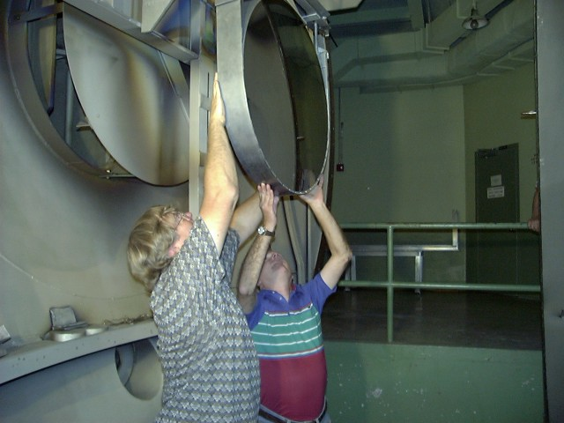
Here’s the final product.

Removal from chamber

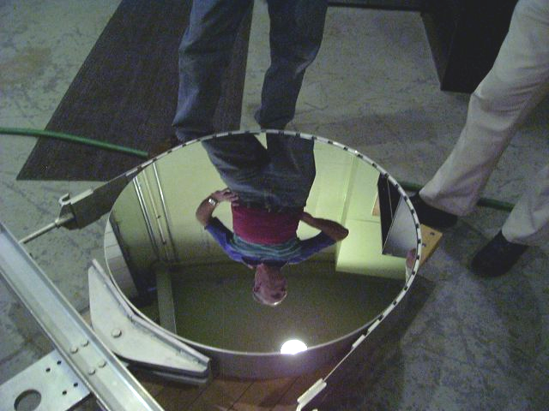
Pretty as a picture!

DSB 15 July 2002

